**Automate an E-Commerce Web Application**

**Screenshots**

**Output:**



**Test Cases:**

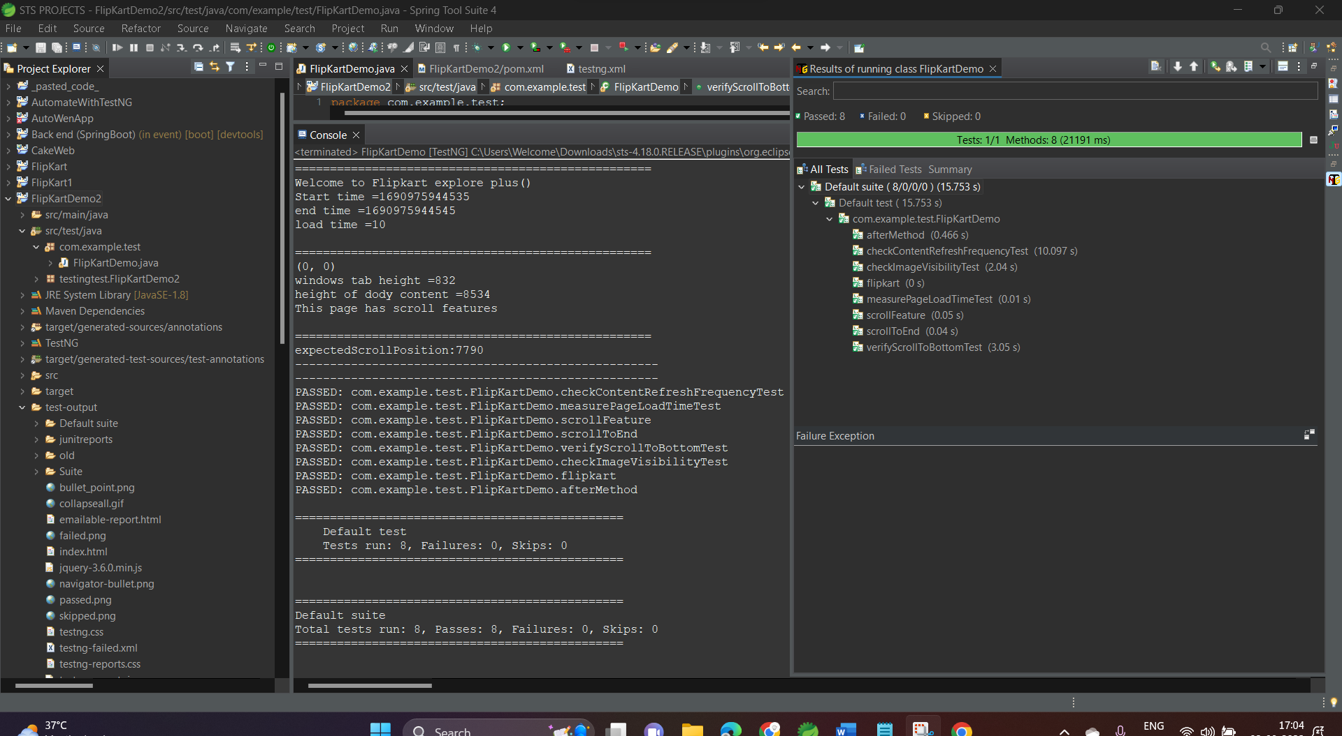

**Home Page:**



**Iphone 13 Search:**



**Scroll to bottom page:**

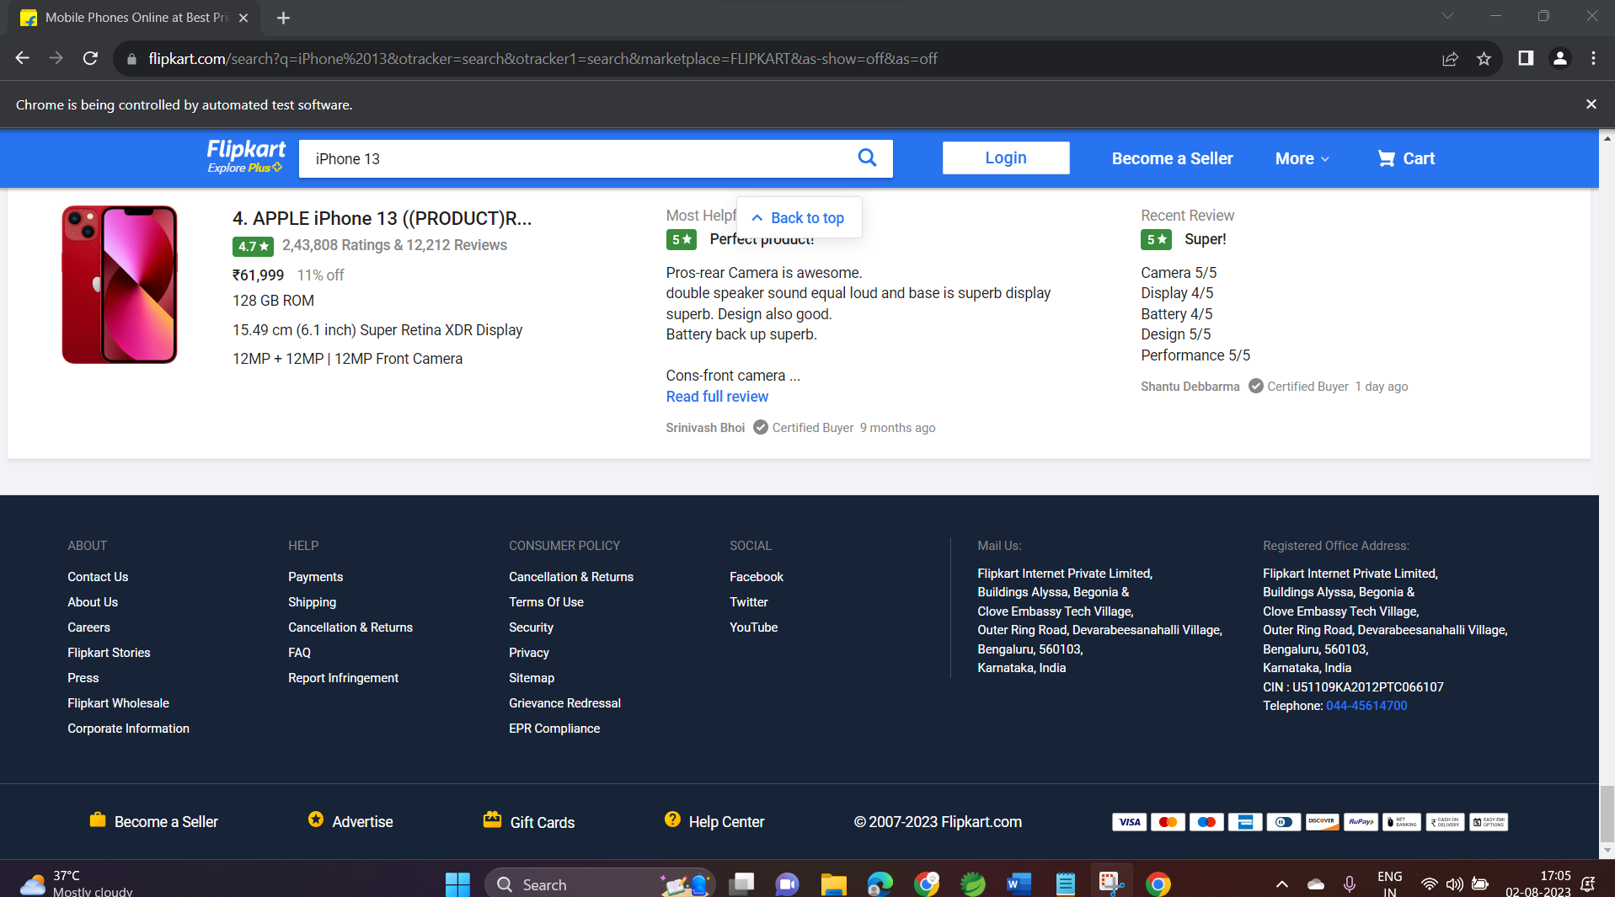

**TestNG Report - emailable-report:**

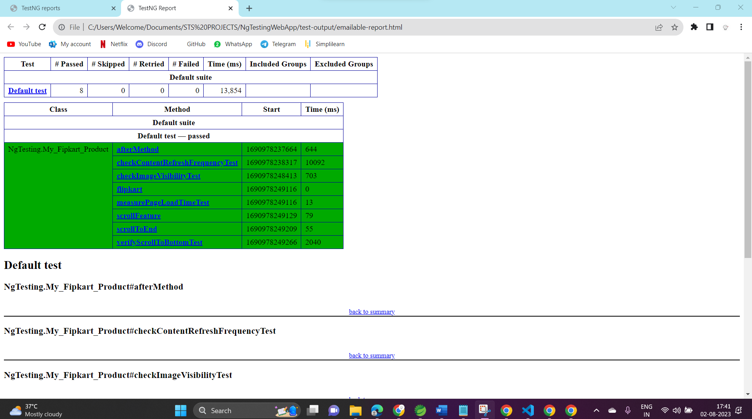

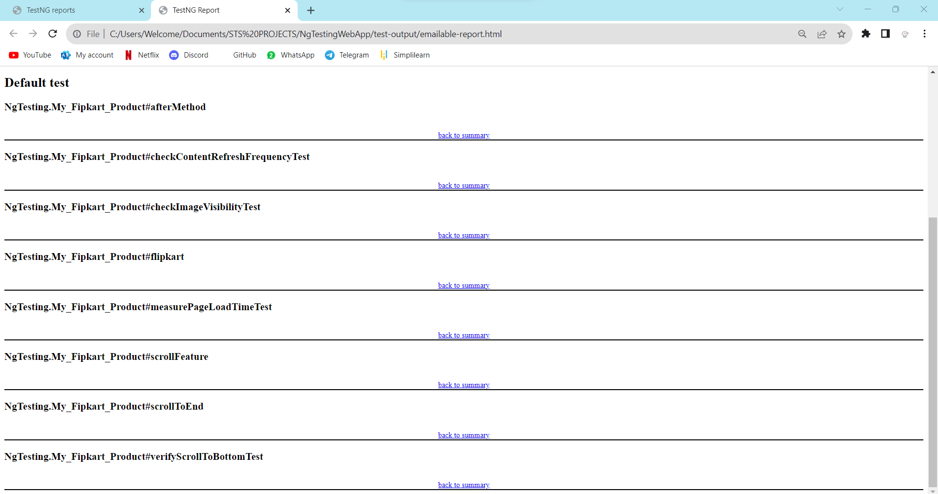

**TestNG Report - INDEX:**

